How to install Windows XP system
Part 1 Install Windows XP system
1. Insert the USB disk, turn on instrument, continually press-release “Del” button until the BIOS screen appears. Move to “Boot” -> select “ Hard Disk Drives” ->press “Enter” to set ”1st Drive” -> select ”USB” ->press “Enter” and click “F10” to save and exit. The instrument will restart.
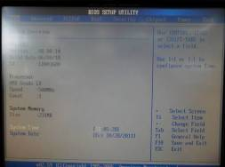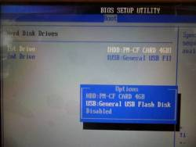
Set “1st drive” to “USB”
Figure 1 BIOS interface Figure 2 Set “1st drive” to “USB”

2. After the instrument restarts, the command interface as Figure 2 will appear.
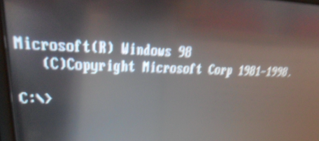
Figure 3 Command interface

3. Type command “cd winxp13” and press “Enter”, then the command line “C:\WINXP13>” occurs. Continue to type command “setup” and press “Enter”, the installation will begin and a progress bar will be shown as Figure 5
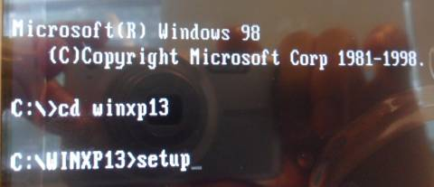
Input these two commands
Figure 4 Input commands
4. After the progress bar appeared 100%, command interface appears again. Please press “Ctrl” + “Alt” + “Del” to restart the instrument and use the same method (press “Del” continually at once) to enter the BIOS.
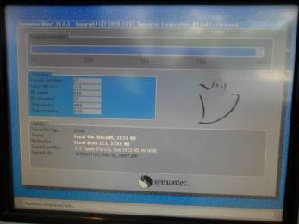
Figure 5 Progress bar

4. Move to “Boot” -> select “ Hard Disk Drives” ->press “Enter” to set ”1st Drive” -> select ”CF card” ->press “Enter” and click “F10” to save and exit. The instrument will restart again.
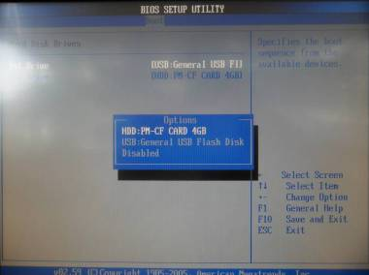
Set “1st drive” to”CF card”
Figure 6 Set “1st drive” to “CF”
5. When the instrument restarts, the Windows XP system reinstallation is finished.

Part 2
1. After the instrument restart, it will open the Windows interface as figure 7. There is no software in the Disk D. Please copy the software in the USB disk, and insert the USB disk on the instrument.
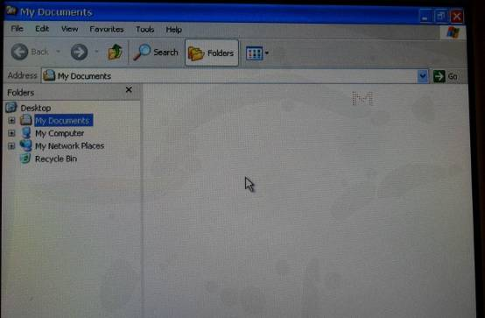
Figure 7 Windows interface
2. Open the USB disk, find the software folder “RTHemat”, copy and paste into Disk D.
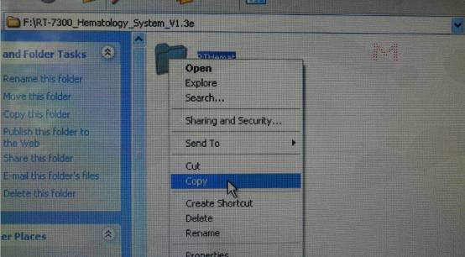
Figure 8 Copy software
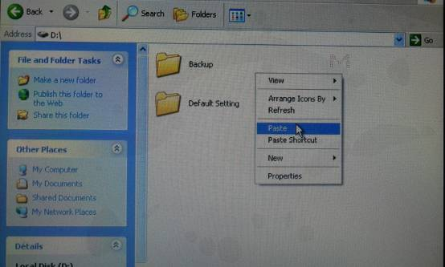
Figure 9 Paste software into disk D
3. Go into the folder “RTHemat”, and double click the “RTHemat.exe” file. The software will be opened.
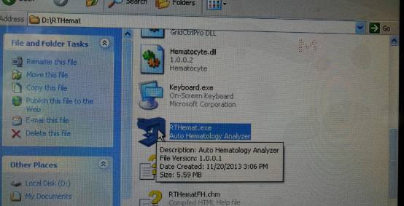
Figure 10 Open software
4. Now, the installation of the WindowsXP and software upgrade is finished. If you find the display on the screen is not whole screen, that’s the resolution problem, please check the instruction “How to change the resolution of the screen”.

